The following agreement is between the Morgan Art of Papermaking Conservatory & Educational Foundation ("Morgan Conservatory") and ("the Artist"), as a binding contract for the Artist to exhibit at Morgan Conservatory's gallery from November 30, 2019 (opening night) through December 21, 2019 (closing date). Morgan Conservatory will assume full responsibility for any lost, stolen or damaged work while in its possession. The gallery will take 30% for any sales on artwork for the duration of the exhibit and the Artist will be paid within thirty (30) days of the exhibition’s closing date.

The Morgan Conservatory will be responsible for:
- Reception costs food/beverage
- Design/marketing/PR
- Gallery Director/open gallery hours/staff
- General exhibition hardware for installation
- Insurance on all artworks exhibited

The artist will be responsible for:
- Marketing materials due by November 16, which include:
→ list of exhibiting artwork with titles, media, and prices
- Shipping costs for artwork to and from Morgan Conservatory
- Timely pickup/drop off of artwork: artwork must be picked up within a week after closing. The Morgan Conservatory is not liable for any artwork left after this time.
- Rights to use artwork images for publicity and publication to promote the exhibition

Artist Name Date

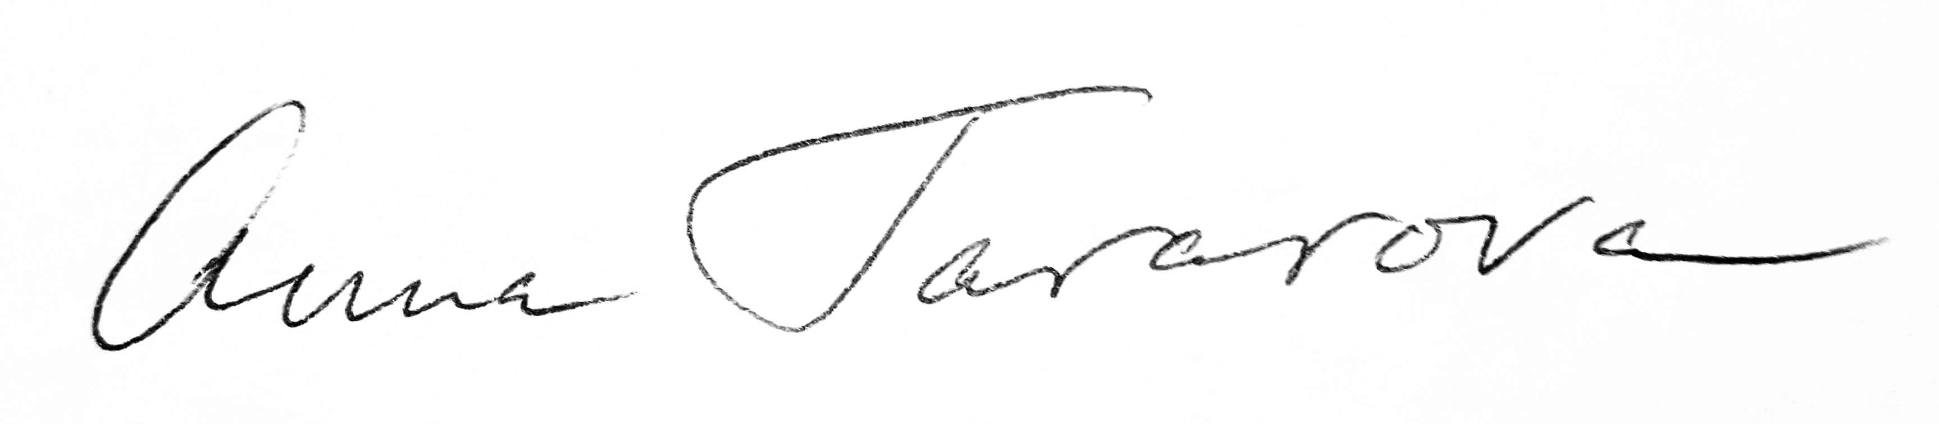
10/20/19

Morgan Conservatory Representative Date

Artist Mailing Address: Artist Phone/Email:

Holiday Sale Item List (add more pages if necessary)

- Title:

Media:
Price:
- Title:

Media:
Price:
- Title:

Media:
Price:
- Title:

Media:
Price:
- Title:

Media:
Price:
- Title:

Media:
Price:
- Title:

Media:
Price:

