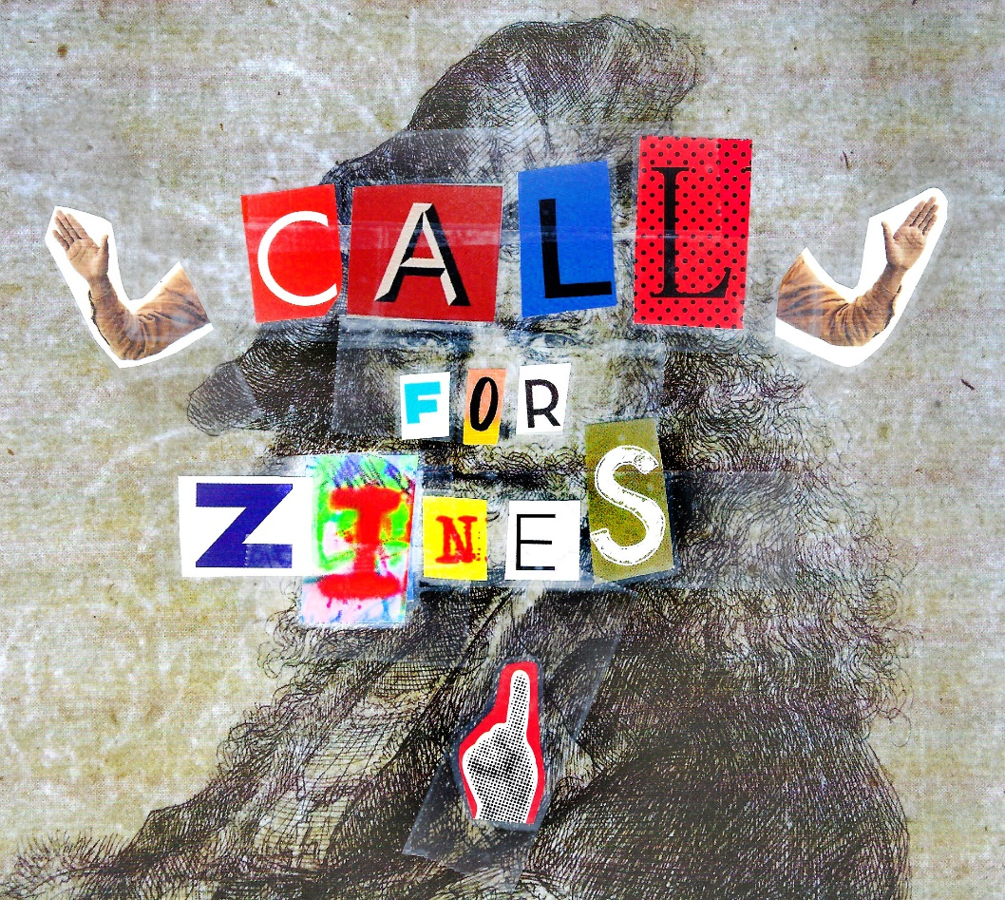
CALL FOR ZINES:
The Morgan Conservatory gallery will house a zine library during the Printmaking as Resistance exhibition October 18th through November 16th, 2019.
Participation in the zine library is open to anyone interested in displaying their publications. Zines on the topics of social issues, civil rights, politics, environment, political art are encouraged, but all other topics are welcome. Morgan Conservatory reserves the right to reject any publications that contain racist, sexist, homophobic or oppressive materials. The library will be open Tuesday through Saturday 10am to 4pm, during Morgan Conservatory business hours. There will be a section of publications available for purchase.
At the closing of the exhibition, zines will be returned to their creators unless they choose to donate them to Morgan Conservatory archives.

To participate in the zine library
Send or deliver one copy per publication to:
Attn: Zine Library
Morgan Conservatory
1754 E 47th St
Cleveland, OH
44103
Include a SASE (self addressed stamped envelope) or a prepaid shipping label if you’d like your zines returned to you at the closing of the exhibition.

To sell your zines
Fill out the attached consignment contract and include it in your package.
Send or deliver up to 5 copies per publication to:
Attn: Store
Morgan Conservatory
1754 E 47th St
Cleveland, OH
44103

