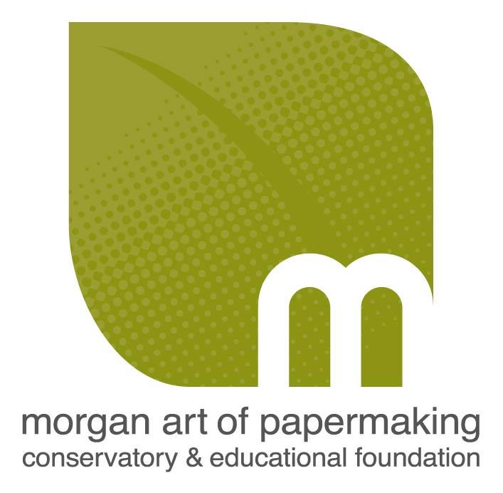

Contact: Anna Tararova
Morgan Art of Papermaking
Conservatory & Educational Foundation
1754 E. 47th St. Cleveland, OH 44103 216.361.9255
atararova@morganconservatory.org

CALL FOR WINTER INTERNSHIP APPLICATIONS

Winter Studio Internship Overview
The Internship Program has been an integral part of the Morgan Conservatory since it’s creation in 2008, proving mutually beneficial to our interns as well as to the Morgan Conservatory. Interns will be immersed in hand papermaking, book arts, and letterpress in exchange for completing tasks that include, but are not limited to paper production, maintaining the studios, and other general housekeeping and assigned tasks. Winter interns will be engaged with the Eastern papermaking processes including processing Kozo plants harvested from our garden and training for production of Eastern papers.
Our goal is that every intern gains the understanding of the process of papermaking by the end of their internship term.

​
Arts Administration Internship Overview

Arts Administration interns will have an opportunity to gain experience marketing, fundraising, archiving, and assisting with a variety of special events. Responsibilities may include general administrative support, guest relations, database entry, phone calls, correspondence, fulfilling online store orders, and writing assignments.

​
Requirements
​
The Morgan Conservatory seeks interns who work well independently and collaboratively, take initiative, are willing and able to do physical labor and are able to handle the flowing nature of our working studio. Interns will work under the Gallery & Artist Opportunities Coordinator, Studio Coordinator as well as with our Artistic Director. Tasks may vary day-to-day. All Internships are unpaid, but the hours earned can be credited towards a workshop tuition waiver or studio rental on certain equipment.

​
Eligibility
Internships are available for university undergraduate and graduate-level students and recent graduates of university programs. No prior papermaking experience is necessary to apply. Working artists and exceptional high school students will be evaluated and accepted on a case-by-case basis. College credit for your internship may be arranged through your university.

Duration
10 weeks beginning January, 2020.
4–6 hrs. a day, 10 am - 4 pm
Applicant must commit to minimum two full days – any days of the week, excluding Mondays and Sundays.
(Start and/or end times may be adjusted to accommodate academic schedules.)

Application Guidelines
All applicants must complete and submit the following:
- Application form (http://www.morganconservatory.org/internships)
- Resume: Please outline your past work, volunteer, and internship experience; educational background; relevant course work and workshops taken; activity/club involvement; skills acquired; and two professional or academic references. Additional information may be included as determined by the applicant.
- Cover Letter: Please address the following in your cover letter:
- Are you applying for a Studio Internship or Arts Administration Internship?
- Why are you interested in an internship at the Morgan Conservatory?
- How would this internship benefit your academic or career goals?
- What do you hope to learn and achieve as a result of your internship?

Deadline: November 24, 2019
All applicants will be informed of their consideration status by email within two weeks following the deadline.
Applications should be submitted electronically via email.
Please see the Application Form for details.
For inquiries or to submit your application, email: atararova@morganconservatory.org or call us at 216.361.9255

